Administrators and users with both the form\_admin and personalize\_form roles can customize the layout for any form view.

# 2 Personalizing Forms

To personalize a form:

1. Right-click the form header and select **Personalize > Form Layout**.

[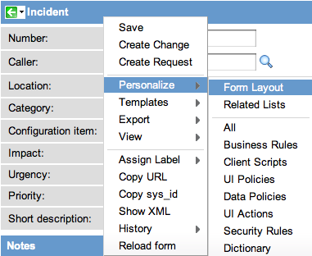](https://wiki.servicenow.com/index.php?title=File:PersonalizeFormLayout.png)

1. Using the [slushbucket](https://wiki.servicenow.com/index.php?title=Slushbucket), select the fields and the order in which you wish them to appear.
   * Available items that appear in green followed by a plus (+) sign represent related tables. To access fields on these tables, use [dot-walking](https://wiki.servicenow.com/index.php?title=Dot-Walking#Dot-walking_in_List_Collectors).
2. Click **Save**.
   * Note that although the same field may be added to more than one section on a form, this causes inconsistent behavior and is not recommended.

ServiceNow lets users with the *personalize\_list* role (including administrators) personalize the columns in any list to show only the desired information. You can add or remove fields (columns) from a list or change the order in which the fields appear in the list. You can hide controls and define access conditions by role to existing controls. To personalize a list, bring up the list, right-click the list's header bar, and select **Personalize**. This opens a cascading menu with the following list options:

* List Layout
* List Calculations
* List Control

[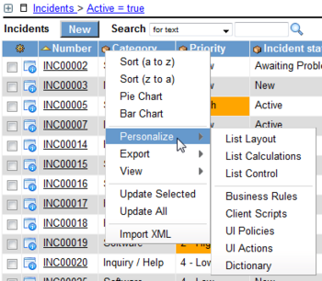](http://wiki.servicenow.com/index.php?title=File:PersonalizeListLayout1.png)

# List Layout

To change the default columns for a list view:

1. Open the list in the view you wish to modify.

For example, to modify the incident mobile view, navigate to **Incident > Open** and select **View > Mobile** from the context menu.

1. Right-click the header and select **Personalize** > **List Layout**.
2. Use the [slushbucket](http://wiki.servicenow.com/index.php?title=Slushbucket) to select the columns and the order in which you wish them to appear.

The first non-reference field automatically links to the form view of the record. For this reason, consider using the record number as the first column in the list layout.

The individual pieces of data in a record are called fields. These fields can be modified using the Record List editor, or using a form. On the form, the fields appear as fields in the form, and in the Record List view they appear as columns of data on the table.

# Creating New Fields

**To add a new field:**

1. Navigate to the form of the new field's table.
2. Right click the form and select **Personalize > Form Layout**.
3. In the **Create new field** section, enter the name of the field and select the field type.

[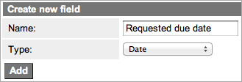](http://wiki.servicenow.com/index.php?title=File:AddNewField.png)

1. Click **Add**.
2. Use the [slushbucket](http://wiki.servicenow.com/index.php?title=Slushbucket) to place the field in the desired location on the form.
3. Click **Save**.

The field now appears on the form in the correct location.

A form displays information from one record in a data table. The specific information depends on the type of record displayed. Users can view and edit records in forms. Administrators can [customize forms](https://wiki.servicenow.com/index.php?title=Personalizing_Forms).

Lists display information from a data table. Users can search, sort, filter, and edit data in lists. Lists also may be embedded in forms and may be hierarchical (have sublists).

An application menu is a group of modules, or pages, that provide related information and functionality in a ServiceNow instance. Administrators can define application menus to group modules under one name in the application navigator. Administrators can also restrict access to application and module listings.

# Creating Modules

1. Open the application menu record by using one of the following methods.
   * Navigate to **System Definition > Application Menus** and select the application menu from the list. In versions prior to [Calgary](http://wiki.servicenow.com/index.php?title=Calgary_Release_Notes), navigate to **System Definition > Applications**.
   * Right-click the application label in the application navigator and select **Edit Application**.
2. Scroll down to the **Modules** related list and click **New**.
3. Define the module by completing the fields on the form (see table).
4. Click **Submit**.

An application is a group of modules, or pages, that provide related information and functionality in a ServiceNow instance. For example, the Incident application contains modules for creating and viewing incidents; the Configuration Management application contains modules for configuring servers, databases, and networks.

The application navigator, or left-navigation bar, provides links to all applications and the modules they contain, enabling users to quickly find information and services. The hide button ([hideNav.png](http://wiki.servicenow.com/index.php?title=File:HideNav.png)) in the banner frame can be used to hide the application navigator.

Administrators can [customize](http://wiki.servicenow.com/index.php?title=Administering_Applications_and_Modules) the application navigator to provide different modules by user role, modify or define applications and modules, and change its appearance.

A table is a collection of records in the database. Tables contain columns, which correspond to fields in the records (or rows) on a table. Applications use tables and records to manage data and processes, such as Incident, Problem, and CMDB. Tables can extend other tables, creating parent tables and child tables (see [Tables and Classes](http://wiki.servicenow.com/index.php?title=Tables_and_Classes)).

Administrators can view and edit table definitions and create new tables with the Tables module.

# Creating Tables

1. Navigate to **System Definition > Tables**.
2. Click **New**.
3. Define the table by completing the fields on the form (see table).
4. Use the **Table Columns** embedded list to [add columns to the table](http://wiki.servicenow.com/index.php?title=Creating_a_Custom_Table#Adding_Columns).
5. Click **Submit** to create the table, or click **Cancel** to close the Table form without creating a new table.

ServiceNow integrates with many third party applications and data sources. The most common integrations are with CMDB, Incident Management, Problem Management, Change Management, User Administration, and Single Sign-on.

A variety of techniques can be used, most notably Web Services, JDBC, LDAP, Excel, CSV, and Email, as well as any industry standard technologies that use SOAP, REST, or WSDL. Additionally, API and command-line integrations can be done using a MID Server. ServiceNow has performed the following integrations with enterprise systems and platforms.

The ServiceNow platform is based on service-oriented architecture (SOA), in which all data objects can use web services to access bi-directional data-level integration.

A gauge is visible on a ServiceNow homepage and can contain up-to-the-minute information about current status of records that exists on ServiceNow tables.  Gauges can be created by the ServiceNow administrator or by users of ServiceNow with the 'gauge\_maker' role.  Gauges can be created from reports or from lists of records on a table and can be sorted and filtered as needed.

The homepage system provides a dashboard full of frequently used content for easy storage. The first page seen upon logging in is the user's personal homepage, and a user can store multiple personal homepages as well as accessing other global homepages that they have the rights to view. Users without roles can view only the ESS homepage. Administrators can create and manage the global homepages.

# 2 Creating a Personal Homepage

Create a personal homepage using the homepage UI in any of these ways:

* Click the "Switch to page" drop-down and select New Page...
* Customize a global homepage created by someone else. This will change the name of the page to indicate the fact that it is a personal homepage, for instance by changing "Admin" to "My Admin."

Administrators can create a personal homepage for themselves or for others using the Homepage Admin > Pages module.

When you add users to your ServiceNow instance, make sure that each user is associated with a group. You should consider which fields are mandatory. Full, complete users profiles are the most useful. Use a unique user ID when creating new profiles or updating existing profiles. If all logs are updated by the **admin** user, it becomes difficult to track what was configured and by whom. Consider creating an ITIL-based role for each administrator for these types of tasks. This role is helpful when interacting with ServiceNow as a user. To import large numbers of users at once, consider using [Import Sets](https://wiki.servicenow.com/index.php?title=Import_Sets).

# Creating a User

1. Navigate to **User Administration > Users**.

[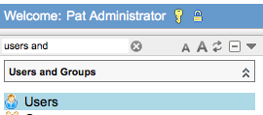](https://wiki.servicenow.com/index.php?title=File:CreateUser.png)

1. Click **New**.
2. Enter the user's information

# Associating the User to a Group

1. Navigate to **User Administration > Groups.**
2. Click the group to which you want to assign the user.
3. From the **Group Members** section, click **Edit**.
4. Select the newly-added user(s), and then click **Add**.
5. Click **Save**.

# 5 Assigning Roles to the User

A user automatically inherits roles from all groups to which that user belongs. These roles cannot be deleted from the user's record, only from the group's record. Roles can also be associated manually from the user's form.

To add roles to a user's record:

1. Open a user's record.
2. From the **Roles** related list, click **Edit**.
3. Select the desired roles and click **Add**.
4. Click **Save**.

A group is a set of users who share a common purpose. Groups may perform tasks such as approving change requests, resolving incidents, receiving email notifications, or performing work order tasks. Any business rules, assignment rules, system roles, or attributes that refer to the group apply to all group members automatically. Users with the user\_admin role can create and edit groups.

# 2 Creating Groups

1. Navigate to **User Administration** > **Groups**.
2. Click **New**.
3. Fill in the form.

To see some of the fields, you may need to [personalize the form](http://wiki.servicenow.com/index.php?title=Personalizing_Forms).

# Adding Users to Groups

After defining a group, add users to the group.

1. Navigate to **User Administration > Groups**.
2. Click a group **Name**.
3. In the **Group Members** related list, click **Edit**
4. Select one or more names in the **Collection** list.
5. Click **Add.**
6. Click **Submit.**

# 4 Removing Users from Groups

You can remove users from a group at any time.

1. Navigate to **User Administration > Groups**.
2. Click a group **Name**.
3. In the **Group Members** related list, select the check box next to a group member name.
4. From the **Actions on selected rows** menu, select **Delete**.

A role is a category that can be assigned to a group or user, and can be granted access to particular parts of the system. Once access has been granted to a role, all of the groups or users assigned to that role are granted the same access. Roles can also contain other roles, and any access granted to one role will be granted to any role that contains it.

# Creating Roles

1. Navigate to **User Administration > Role**.
2. Click **New**.
3. Give the role a unique, descriptive name and a brief description.
4. Click **Submit**.

The new role appears on the Roles list. It does not have access to any applications or modules until you add other roles to it or add the new role to the appropriate applications and modules.

1. To add other existing roles to the new role, open the role in form view and click **Edit** in the **Contains Roles** Related List.

Use the slushbucket to add the appropriate existing roles to the new role and click **Save**. Users who are assigned the new role automatically inherit access to the same applications and modules as the existing roles added here.

1. To create a role to add to the new role, click **New** in the **Contains Roles** Related List.
2. To give the role access to additional applications or modules:
   1. Navigate to **System Definition > Applications** or **System Definition > Modules**.
   2. Click the appropriate application or module to open it in form view.
   3. Click the lock to open the **Roles** field.
   4. Use the slushbucket to add the desired roles to the application or module.
   5. Click the lock to close the **Roles** field, then save your changes.

Service delegation is the ability to designate other users to receive and interact with approvals and tasks assigned or sent to you, and to receive copies of all email notifications sent to you.

ServiceNow uses access control list (ACL) rules, also called access control rules, to control what data users can access and how they can access it. ACL rules require users to pass a set of requirements in order to gain access to particular data. Each ACL rule specifies:

* The **object** being secured
* The **permissions** required to access the object

ServiceNow searches for ACL rules that **match** the object the user wants to access. If there are no matching ACL rules for the object, then the object does not require any additional security checks. By default, ServiceNow provides ACL rules to restrict access to all database and personalization operations.

After finding a matching ACL rule, ServiceNow *evaluates* if the user has the permissions required to access the object. If a user meets the ACL rule permissions, the instance grants the user access to the object. If a user does not meet the ACL rule permissions, the instance denies the user access to the object.

[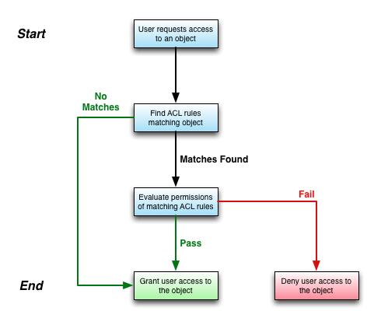](http://wiki.servicenow.com/index.php?title=File:Acl_workflow.png)

ACL Rule Workflow

Users with access to the security\_admin role can:

* [Create ACL rules](http://wiki.servicenow.com/index.php?title=Using_Access_Control_Rules#Creating_ACL_Rules) to secure new objects
* Update existing ACL rules to [grant or deny users access](http://wiki.servicenow.com/index.php?title=Using_Access_Control_Rules#Granting_or_Denying_Access) to objects based on their business requirements
* [Debug ACL rules](http://wiki.servicenow.com/index.php?title=Using_Access_Control_Rules#Debugging) to determine why users cannot access certain objects

The contextual security manager provides incredible flexibility and power to protect information by controlling read/write/create/delete authorization. Key advantages include:

* Contextual Security -- Secure a record based on its contents
* Hierarchical Security -- Can apply security rules to any level in our object hierarchy
* A metric measures and evaluates the effectiveness of IT service management processes. For example, a metric could measure the effectiveness of the incident resolution process by calculating how long it takes to resolve an incident.
* Sometimes a metric can be easily obtained from the data. For example, to find the number of incidents that were created today, a report will simply count the number of incidents in the incident table with a Created date of today. Often, however, metrics need to be gathered as data is updated. For example, determining how long an incident was assigned to a certain group requires collecting information about assignment changes and calculating the duration of each assignment.
* The Metric plugin provides an easy, declarative way of defining metrics. Once defined, the data for the metric will be gathered, and instances of the metric will be calculated and stored. By an instance we mean a specific occurrence. For example, the “Assigned to Duration” metric measures the duration of time an incident is assigned to an individual. The metric is defined by creating a metric definition of type “Field value duration” and selecting the “Assigned to” field from the Incident table. A metric instance is then created for each incident assignment showing its duration. Reporting on the duration of incident assignments becomes easy.

ServiceNow puts the power of report creation in the hands of every user of the system. Administrators can create reports that are viewable by specific groups, or by everybody. Individual users can create custom reports that they can access at any time. Reports can be scheduled for email delivery at specific times of the day, week or month, internally and externally. Any report can be made into a gauge which can be added to a ServiceNow homepage. Combine these powerful features with over 60 customizable, commonly used reports that are delivered with ServiceNow, and you have the most robust native reporting tool available in any ITSM application on the market today.

**Running Reports**

Reports can be accessed through the left navigation bar. Here are some quick definitions of the modules in the Report application:

* View/Run - The list of available reports. This list will be based on the role the logged in user has to access individual reports. From this list users can either create a new report or click on any available report to run it.
* Chart Colors - The colors of specific sets of data in viewed graphical reports. Once any graphical report is rendered in ServiceNow, a list of records will be added to this table showing the attributes of what report, what data set and what color is displayed on that report. By clicking into any of these records, you can adjust the color used in the report.
* Color Definition - The available colors which can be accessed for graphical reports. ServiceNow comes with 143 predefined colors; you can create new ones if you choose, or use this list as a reference guide for customizing the look of your existing graphical reports.
* Scheduled Reports - This is the list of reports that have been scheduled to run at specific times. If an individual is receiving a report at a specific interval, this is where you'll find it scheduled.

**4 Creating a Report**

1. From the left navigation pane, select **Reports > View/Run**.
2. Click the [Image:New_gray.png](http://wiki.servicenow.com/index.php?title=File:New_gray.png)button at the top of the list.
3. Define the parameters of the report.
4. Click the **Save** or **Insert** button.

|  |  |
| --- | --- |
| [Note](http://wiki.servicenow.com/index.php?title=File:Warning.gif) | **Note:** *When saving a report, avoid characters such as '&', ';', or ','.* |

**4.1 Editing an Existing Report**

1. From the left navigation pane, select **Reports > View/Run**.
2. Open a report from the list.
3. Adjust any parameters as needed.
4. Save the report, and then return to the report list.

* **Update** - Overwrite initial report, returning to the report list
* **Save** - Overwrite initial report, staying on the report form
* **Insert** - Create a new report. Be sure to change the name

|  |  |
| --- | --- |
| [Note](http://wiki.servicenow.com/index.php?title=File:Warning.gif) | **Note:** *If a non-admin user is viewing a global report, clicking* ***Update*** *or* ***Save*** *will not overwrite the initial report: instead, it will save/update a personalized version of a report belonging to the user.* |

**4.2 Creating a Report from a List**

1. Navigate to the list for which you want to create a report.
2. Right click on the column header you want to group your report by.
3. Select **Pie Chart** or **Bar Chart** from the drop-down menu.
4. Click the [Image:Expander_icon.png](http://wiki.servicenow.com/index.php?title=File:Expander_icon.png)icon to the left of the **Reports** link.
5. Save the report:
   * **Update** - Overwrite initial report, staying on the report form
   * **Save** - Overwrite initial report, returning to the report list
   * **Insert** - Create a new report. Be sure to change the name, and then return to the report list

**4.3 Scheduling Reports**

|  |  |
| --- | --- |
| [Note](http://wiki.servicenow.com/index.php?title=File:Warning.gif) | **Note:** *You can grant non-admin users rights to schedule reports with the* ***report\_scheduler*** *role.* |

Scheduling reports is a powerful way to automate distribution of the current status of your database tables. Instead of spending time creating Access or Excel reports and emailing them to team members or executives, you can create a report and let ServiceNow periodically run it and email the output to the appropriate parties automatically. Scheduled reports created by an individual whose user account is deactivated might not display any data. To ensure that the desired data is displayed, an active user must recreate the scheduled report.

1. Open a report that you want to schedule for distribution.
2. Click the **Schedule** at the top of the report.
3. Select the **Users**, **Groups**, or any undefined email addresses you want the report to reach.
4. Define the **interval** and **time** you want the report to be distributed at.
5. Define a **subject** for the email.
6. Define any ***text*** information you want to accompany the report, which is sent as an attachment to the email.
7. Choose an output **Type** for the report.
8. Check the **Zip Output**box send the output as a .zip file.
9. Click **Submit**.

Reports are distributed via email. Calendar reports are not currently supported for automatic emailing.

Available report output **Type** field selections are **PDF**, **PDF-landscape**, **Excel**, **CVS**, and **PNG**. Graphical reports are sent as .png or .pdf files and text reports (lists) are sent as .pdf files. When scheduling a graphical report to be emailed, select output type **PDF** or **PDF-landscape** to include the chart grid data. (Include Grid should be checked on the report.)

A user must have Notification set to "Email" on their user record to receive reports. An exception to the above is that an email address directly specified in the "To these addresses" field will always receive the report, even if there's a matching user record for that address that says "Do not notify".

You can add the **Include detail** field by [personalizing the form](http://wiki.servicenow.com/index.php?title=Personalizing_Forms). Selecting the **Include detail** field for a list report includes a form view for all records from the selected list in the report.

|  |  |
| --- | --- |
| [Note](http://wiki.servicenow.com/index.php?title=File:Warning.gif) | **Note:** *To change the time zone of a scheduled report, run as a user with the desired time zone.* |

**4.3.1 Scheduling Multiple Reports**

To schedule multiple reports:

1. Navigate to **Reports > Scheduled Reports** and click **New**.
2. Populate the [form](http://wiki.servicenow.com/index.php?title=Creating_Reports#Creating_a_Scheduled_Job.23Scheduling_a_Report).
3. Save the record.
4. Use the **Included in Email** related list to create additional scheduled reports.

The **Included in Email** related list will include those reports when the parent report is emailed.

**4.3.2 Scheduling Reports as a Report**

Scheduled reports are distributed as attachments of different kinds.

**To send the report as a link:**

1. Navigate to **Reports > Scheduled Reports** and click **New**.
2. Populate the [form](http://wiki.servicenow.com/index.php?title=Creating_Reports#Creating_a_Scheduled_Job.23Scheduling_a_Report), leaving the **Report** reference blank.
3. Get the **sys\_id** of the desired report and put the link in the **Introductory Message** field.
   * To link the user directly to the report, substituting the instance name and **sys\_id**.

<https://INSTANCENAME.service-now.com/sys_report_display.do?sysparm_report_id=SYSID>.

* + To link the user to the report in the frameset:

<https://INSTANCENAME.service-now.com/nav_to.do?url=sys_report_display.do?sysparm_report_id=SYSID>.

Users can export a report to PDF directly from the report form using the **Export to PDF** button

Service Level Agreements (SLAs) allow the service desk to track whether or not their representatives are providing a certain level of service. The most common use of SLAs is to ensure that incidents are resolved within a certain amount of time.

A Service Offering SLA is an SLA that applies only to service offerings for business services (requires [Service Portfolio Management plugin](http://wiki.servicenow.com/index.php?title=Service_Portfolio_Management_Plugin) and [Service Portfolio Management - SLA Commitments plugin](http://wiki.servicenow.com/index.php?title=Service_Portfolio_Management_-_SLA_Commitments_Plugin)). To define a service offering SLA, navigate to **Business Services > Service Offering SLAs > SLAs**

**Defining an SLA**

When defining an SLA, the **Duration** field, in coordination with the **Schedule** field, is critical. For example, select a 5 day 2 hour duration and a 9-5 schedule. The 5 days and 2 hours are considered 122 hours (5x24 + 2). The 122 hours are distributed across the 9-5 schedule at 8 hours per day resulting in 15.25 schedule days (122/8 = 15.25).

To define an SLA:

1. Navigate to **Service Level Management > SLA Definitions**.
2. Click **New**.
3. Fill in the form.

**Defining the SLA**

To define the SLA, navigate to **Service Level Management > SLA Definitions**, and click new.

Populate the fields with the following:

* **Name** - Name the incident **Priority 1 Paris Incident**.
* **Type** - Specify the type as SLA. Although the type does not change the behavior of the SLA, the type will help distinguish between agreements with customers, vendors, and internal departments.
* **Workflow** - Select **Default SLA Workflow**. To learn how to create a custom Workflow for SLAs, click [Creating a Service Level Management Workflow](http://wiki.servicenow.com/index.php?title=Creating_an_SLA_Workflow).
* **Duration Type** - Select **End of next business day.** This means that, regardless of when the ticket is opened, the SLA will calculate the end of the next business day and set that as the deadline for the SLA.
* **Schedule** - Select **8-5 weekdays**. This means that the timer will run between the hours of 8 and 5 on weekdays.

Once those fields are populated, it is important to populate the condition fields:

* **Start Condition** - Set the following conditions: **Location is Paris**, **Priority is 1 - Critical**, and **Active is True**. Now the SLA will attach to any active Priority 1 incidents in Paris.
* **Stop Condition** - Set the condition **Active is False**. This means that once the incident is closed or resolved, the SLA will stop tracking time.
* **Pause Condition** - Set the conditions **Incident is one of Awaiting Problem, Awaiting User Info, or Awaiting Evidence**. This will avoid tracking time while the service desk is waiting for outside events.

The form should look like this:

[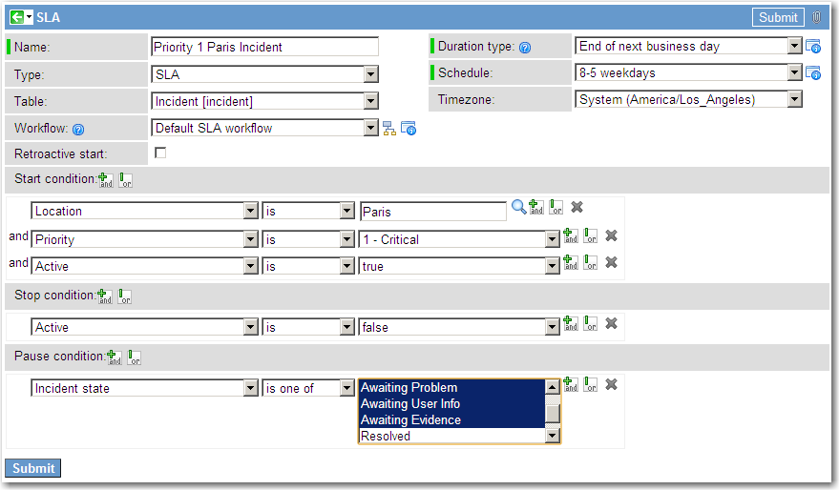](http://wiki.servicenow.com/index.php?title=File:SLA_Example.png)

The result is that whenever an incident is listed as being Priority 1 incident in Paris, the following workflow will be launched:

**Creating an SLA Workflow**

To create an SLA workflow, navigate to **Service Level Management > Workflow Editor**. This launches the Graphical Workflow Editor. Select **New** in the top left, and populate the first form as follows:

* **Name:** *Urgent SLA Workflow*.
* **Table:** *Task SLA [task\_sla]*. All SLA workflows must be on the Task SLA table regardless of what table the SLA will be running against.
* **If Condition Matches:** *--None--*. Because no conditions will be specified since it is set to none, the SLA will not run unless specified by a particular SLA.

The form should now look like this:

[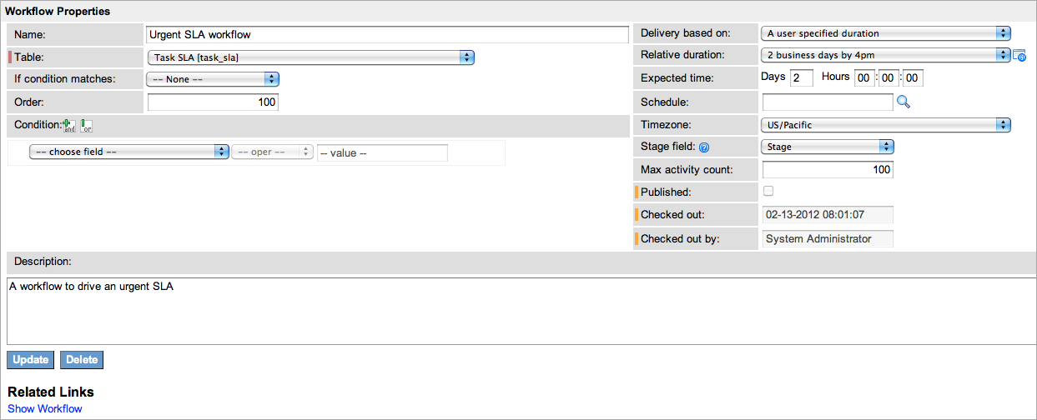](http://wiki.servicenow.com/index.php?title=File:Workflow_Properties.png)

Click **Update**. There is now a workflow with a beginning and end. Now it is time to specify what will happen when the Urgent SLA workflow is triggered.

Suppose the desired process is:

* After 33% of the SLA's duration, alert the user assigned to responding to the task.
* After 66% of the SLA's duration, notify the assignee's manager.
* After 100% of the SLA's duration, notify the Customer Care representative that the SLA has been breached.

To define that process as a workflow:

1. Drag the activity **SLA Percentage Timer** onto the arrow between **Begin** and **End**.
2. Name the activity **33% Timer** and enter **33** in the **Percentage** field.
3. Drag the activity **Notification** into the empty space below the **33% Timer** activity.
4. Name the activity **Notify Assignee**.
5. Click the lock icon on the **To** field, select the variable picker ([Image:VariablePicker.png](http://wiki.servicenow.com/index.php?title=File:VariablePicker.png)), and select **Task SLA > Task > Assigned To.**

[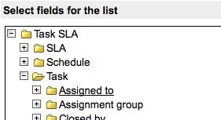](http://wiki.servicenow.com/index.php?title=File:Variablepicker2.png)

Enter a subject and email body as necessary.

[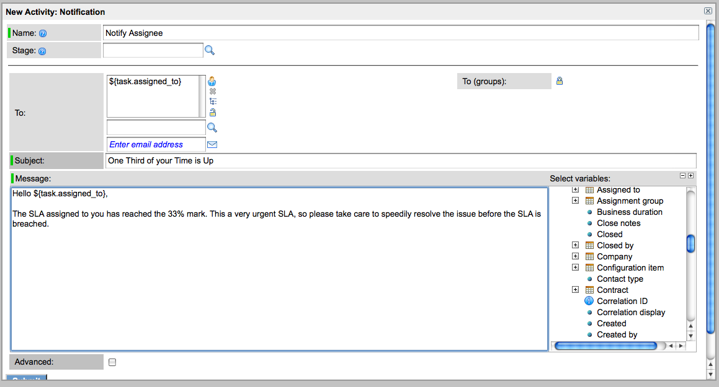](http://wiki.servicenow.com/index.php?title=File:Notification.png)

1. Click the yellow box on the side of the **33% Timer** activity and drag to the new notification box. This creates a second arrow from **33% Timer** to the new notification:

[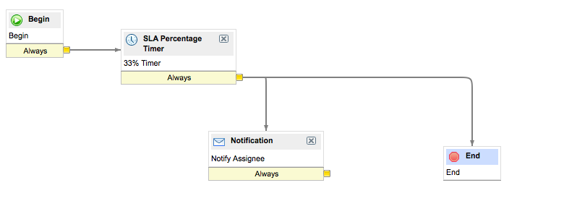](http://wiki.servicenow.com/index.php?title=File:SLA_Workflow2.png)

1. Drag the activity **SLA Percentage Timer** onto the arrow between **33% Timer** and **End**.
2. Name the activity **33% Timer 2** and enter **33** in the **Percentage** field.
3. Drag the activity **Notification** into the empty space below **33% Timer 2** activity.
4. Name the activity **Notify Assignee's Manager**.
5. Click the lock icon on the **To** field and select **Task SLA > Task > Assigned To > Manager.**
6. Click **Submit**.
7. Drag an arrow from **33% Timer 2** to the new notification box.
8. Drag the activity **SLA Percentage Timer** onto the arrow between **33% Timer 2** and **End**.
9. Name the activity **33% Timer 3** and place **33** in the **Percentage** field.
10. Drag the activity **Notification** into the empty space below the **33% Timer 2** activity.
11. Name the activity **Notify Customer Care**.
12. Click the lock icon on the **To** field, locate the **Enter Email Address** field, and enter **customercare@yourcompany.com**.
13. Click **Submit**.
14. Drag an arrow from **33% Timer 3** to the new notification box.

The workflow should now look like this:

[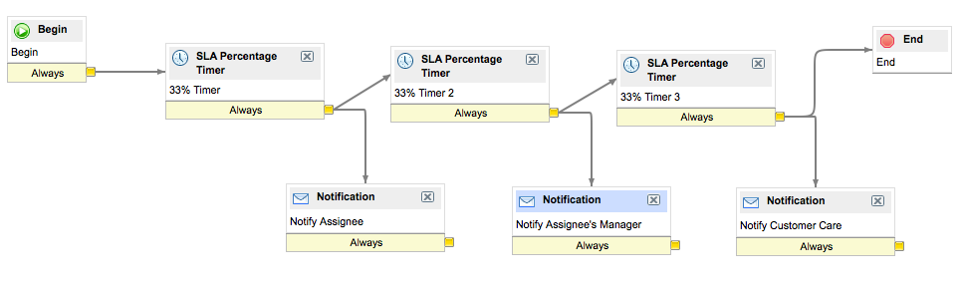](http://wiki.servicenow.com/index.php?title=File:SLA_workflow3.png)

1. Click the Workflow Actions icon [Image:Workflow Actions.png](http://wiki.servicenow.com/index.php?title=File:Workflow_Actions.png)and select **Publish**.

The workflow will now be available to any SLA, and can be edited at any time by opening the workflow editor, opening the workflow, and checking it out.

All users of the ServiceNow application can access the knowledge portal to search for and view role-appropriate articles. The specific application and modules available vary by role.

The separate Employee Self-Service portal allows employees to access knowledge articles outside the full ServiceNow application.

**Accessing Knowledge**

View role-appropriate knowledge articles from these locations.

* **Knowledge portal:** every ServiceNow user can access the knowledge portal through one of these paths: **Self-Service > Knowledge**, **Service Desk > Knowledge**, or **Knowledge Base > View**

**Knowledge base list:** users who click a topic's **View all items** link on the knowledge portal see a list of all articles in that topic that have not passed their *valid to* date. Unlike a [record list](http://wiki.servicenow.com/index.php?title=Using_Lists), users cannot alter knowledge base entries with the list editor.

**Searching the Knowledge Base**

Find a specific article by searching the knowledge base in one of these ways:

* [**Knowledge search:**](http://wiki.servicenow.com/index.php?title=Searching_Knowledge) the search field above the knowledge page searches knowledge articles and their attachments by default. This search, available to all users, lets users filter, organize, and refine search results. Use advanced search to filter search results by topic, category, and search location. Administrators can [restrict this function](http://wiki.servicenow.com/index.php?title=Administering_Knowledge_Search).
* [**Global text search:**](http://wiki.servicenow.com/index.php?title=Using_Global_Text_Search) available to users with role-based permissions, the global text search field in the banner frame searches the knowledge base as well as other types of records to which the user has access rights.
* [**Forms:**](http://wiki.servicenow.com/index.php?title=Searching_Knowledge#Searching_Knowledge_from_Forms) the search knowledge icon ([Book.png](http://wiki.servicenow.com/index.php?title=File:Book.png)), which appears on some forms, launches a knowledge search for the text in the adjacent field. This icon appears beside the **Short description** field on the Incident and Problem forms by default; administrators may add it to other forms. The search results and articles appear in a pop-up window. You can click the **Attach to Task** button (the word *task* is replaced by the task name) in an article to add information about the article to the associated task record.
* [**Content pages:**](http://wiki.servicenow.com/index.php?title=Content_Management_Overview) created with the Content Management System (CMS), content pages can include knowledge search options.

Catalog items are goods or services available to order from the service catalog. Administrators and users with the catalog\_admin role can define catalog items, including formatted descriptions, photos, and prices.

# Defining Catalog Items

To define a catalog item:

1. Navigate to **Service Catalog > Catalog Definition > Maintain Items**.
2. Click **New**.
3. Enter the catalog item details (see table).
4. Click **Submit**.

A record producer is a specific type of catalog item that allows end users to create task-based records (such as incident records) from the service catalog. Record producers provide a simplified alternative to the regular ServiceNow form interface for creating records.

To define a record producer:

1. Navigate to **Service Catalog > Catalog Definition > Record Producers**.
2. Click **New** or select the record producer to edit.
3. Fill in the fields on the Record Producer form (see table).
4. Click **Submit**.

After you submit the form, ServiceNow adds the **Variables** and **Variable Sets** related lists.

1. Open the record again to define [variables](http://wiki.servicenow.com/index.php?title=Using_Service_Catalog_Variables) for the record producer.

Administrators and users with the catalog\_admin role can define service catalog variables.

Service catalog variables provide the ability to capture and pass on information about choices a customer makes when ordering a catalog item. Some variables can be defined to affect the order price, depending on the selected value.

For example, a *New PC* catalog item can use a variable called "Memory", which provides choices to allow customers to select extra memory, for associated extra prices.

Variables can be stored, accessed from multiple places, and passed between tasks in a process when [fulfilling a request](http://wiki.servicenow.com/index.php?title=Managing_Request_Fulfillment).

Variables can be displayed on the Requested Item and Catalog Task forms after an item has been ordered.

ServiceNow provides a full set of [variable types](http://wiki.servicenow.com/index.php?title=Variable_Types).

## 1.1 Defining and Associating Variables

Variables can be associated with individual [catalog items](http://wiki.servicenow.com/index.php?title=Defining_Catalog_Items), so that they are available in any request for the item (regardless of the workflow or execution plan used). Variables can also be associated with [variable sets](http://wiki.servicenow.com/index.php?title=Service_Catalog_Variable_Sets) and re-used across multiple catalog items.

See [Using Service Catalog Variables](http://wiki.servicenow.com/index.php?title=Using_Service_Catalog_Variables) for instructions on adding service catalog variables to catalog items.

# 2 Passing Variables Between Tasks

Variables are passed from one step of the fulfillment process to another. They can be processed by any [workflow](http://wiki.servicenow.com/index.php?title=Service_Catalog_Workflows) or [execution plan](http://wiki.servicenow.com/index.php?title=Using_Execution_Plans) that is associated with the requested items.

For example, consider the following tasks within the fulfillment process for a *New PC* catalog item.

1. Procure PC.
2. Install corporate standard software.
3. Set up email account.
4. Deliver and set up PC for requester.

Step 4 may require a piece of information from step 3 (the email account credentials for setting up email on the PC). If steps 3 and 4 are executed by different fulfillment groups, you can use variables to make this information visible in the tasks for steps 3 and 4, and to pass it between groups so that the second group can access the email account credentials.

An order guide gives customers an easy way to order multiple related items as a single request, It uses :

* A single initial screen, where the customer fills in some initial information.
* A set of selected catalog items based on conditions derived from the initial information.

For example, a New Employee Hire order guide contains items that new employees typically receive, from which the customer selects appropriate items and options. If the new employee selects the optional business cards, that item is then included as part of the request.

# 2 Creating Order Guides

To create an order guide:

1. Navigate to **Service Catalog > Catalog Definition > Order Guides**.
2. Click **New**.
3. Enter these order guide details and save the record.
   * **Name:** enter the guide name to appear in the catalog.
   * **Order to cart:** select the check box to allow users to continue shopping after completing the order guide. When this check box is selected, users see the **Add to Cart** button instead of the **Check Out** button on the order guide (you may need to [personalize the form](http://wiki.servicenow.com/index.php?title=Personalizing_Forms) to add this field).
   * **Two step:** select the check box to enable [two step](http://wiki.servicenow.com/index.php?title=Service_Catalog_Order_Guides#Enabling_Two_Step_Order_Guides) ordering (rather than the default three step ordering).
   * **Category:** select the category heading under which the guide appears.
   * **Short description:** enter a summary of the order guide purpose.
   * **Description:** enter a description that appears on the first page of the order guide. Apply formatting by using the [HTML editor](http://wiki.servicenow.com/index.php?title=Using_HTML_Fields).
4. Define any [cascading variables](http://wiki.servicenow.com/index.php?title=Service_Catalog_Order_Guides#Adding_Cascading_Variables).
5. Define any [rules](http://wiki.servicenow.com/index.php?title=Service_Catalog_Order_Guides#Creating_the_Rule_Base) for including items in the order guide.

**Order guide definition**

## 2.1 Enabling Two Step Order Guides

By default, order guides present the user with a three step process:

1. **Describe Needs:** the initial screen
2. **Choose Options:** filling in details for the items ordered
3. **Check Out:** review and, if necessary, edit item information before submitting the request

Order guides allow for an optional two step mode that omits the Check Out step. Upon completion of the Choose Options step, the selected items are automatically ordered.

To set an order guide to use the two step checkout model, select the **Two step** check box in the Order guide form.

se the [Graphical Workflow Editor](http://wiki.servicenow.com/index.php?title=Graphical_Workflow_Editor) to create service catalog [workflows](http://wiki.servicenow.com/index.php?title=Workflow_Overview) that drive catalog request fulfillment.

After creating a workflow, attach it to any catalog item in the **Workflow** reference field on the item form.

Creating a workflow involves:

* Defining the new workflow fields.
* Defining workflow activities.
* Publishing the new workflow.

# 2 Defining a Service Catalog Workflow: Example

This section defines an example service catalog workflow to fulfill a laptop request.

See the standard [workflow documentation](http://wiki.servicenow.com/index.php?title=Workflow_Overview) for more information about defining workflows.

## 2.1 Stage 1: Create a New Workflow

1. Navigate to **Workflow > Workflow Editor**.
2. Select **New**.
3. Fill in the New Workflow form (see the table for field descriptions).
4. Click **Submit**.

ServiceNow displays a graphical representation of the new workflow that shows an **Activities** pane on the right.

An **update set** is a group of customizations that can be moved from one instance to another. This feature allows administrators to group a series of changes into a named set and then move them as a unit to other systems. In most cases, update sets allow customizations to be developed in a development instance, moved to a test instance, and then applied to a production instance.

An *update set* is a group of customizations that can be moved from one instance to another. For example, a set of enhancements to incident management can be grouped in an update set called **Incident Management 2.0**. While **Incident Management 2.0** is marked as the current update set, all changes are tracked in it. Once the update set is marked as complete, it is ready to be moved to a test or production instance.

Each update set is stored in the Update Set [sys\_update\_set] table, and the customizations that are associated with the update set (stored in the Customer Update [sys\_update\_xml] table) appear as a related list on the update set record.

The general process for using update sets is:

1. Review the [Getting Started with Update Sets](http://wiki.servicenow.com/index.php?title=Getting_Started_with_Update_Sets) page to learn how to plan the update process and avoid common pitfalls.
2. Use update sets to make customizations on a development instance.
   * [Create an update set](http://wiki.servicenow.com/index.php?title=Using_Update_Sets#Creating_Update_Sets).
   * [Perform customizations](http://wiki.servicenow.com/index.php?title=Using_Update_Sets#Performing_Customizations_with_Update_Sets).
   * If necessary, [report on updates](http://wiki.servicenow.com/index.php?title=Using_Update_Sets#Reporting_on_Updates).
   * If necessary, [merge update sets](http://wiki.servicenow.com/index.php?title=Using_Update_Sets#Merging_Update_Sets).
   * [Compare local sets](http://wiki.servicenow.com/index.php?title=System_Update_Sets_Preview#Comparing_Local_Update_Sets) to ensure the desired changes are ready to move.
3. [Mark the update set](http://wiki.servicenow.com/index.php?title=Using_Update_Sets#Completing_Update_Sets) as **Complete**.
4. Transfer the update set to another instance according to your test process. See [Transferring Update Sets](http://wiki.servicenow.com/index.php?title=Transferring_Update_Sets).

# 2 Creating Update Sets

To create a new update set:

1. Navigate to **System Update Sets > Local Update Sets** and click **New**.
2. Enter update set details (see table).
3. Click **Submit**.
4. **Update set record**

**Update set record**

|  |  |
| --- | --- |
| **Field** | **Description** |
| Name | Enter a unique name for the update set. You can use naming conventions to organize update sets. For example, add the problem number to the name of the update that fixes it, or use sequence numbers to keep track of the order in which update sets need to be applied. To learn more, see [Getting Started with Update Sets](http://wiki.servicenow.com/index.php?title=Getting_Started_with_Update_Sets). |
| State | Select **In Progress** for a new update set.  **In Progress** update sets can track customizations and can be selected from the Update Set Picker. **Completed** update sets can be transferred from one instance to another.  Select **Completed** only when you are certain that the update set is complete. Once it is marked **Completed**, do not set it back to **In Progress**. Instead, create a new update set with further customizations, and make sure to apply the update sets in the order that they were marked **Completed**.  Select **Ignore** when you are no longer working on an update set but do not want it to be transferred to another instance. You should always set **Completed** update sets on the production instance to **Ignore**. This state ensures the update set is not reapplied when cloning the instance. |
| Created By | Automatically populates your user name when you submit a new update set record. |
| Created | Automatically populates the timestamp when you submit a new update set record. |
| Release Date | Enter the date on which you plan to release the update set. |
| My Current Set | Select the check box to apply your customizations to this update set. This field does *not* apply to all users; it only applies to the user who selects it.  The **Update Set Picker** is a better method for choosing a current set because it appears at the top of the page and allows for easy switching between **In Progress** update sets. |
| Description | Enter a description of the update set. |

# 3 Performing Customizations with Update Sets

To add changes to update sets:

1. Select the desired update set from the Update Set Picker. Any customizations you make are now added to this update set.

**Update Set Picker**

1. Perform a customization on a tracked table.

o retrieve a completed update set from another instance:

1. [Optional] If IP address access control is enabled on the source instance, [set up the target instance as an exception](http://wiki.servicenow.com/index.php?title=Transferring_Update_Sets#Transferring_with_IP_Access_Control).
2. Navigate to **System Update Sets > Update Source** and click **New** to define an update source. Populate the fields as follows:
   * **Name:** enter a unique name that indicates which instance from which this update set source will pull update sets.
   * **Type:** specify whether the source instance is a Development, Test, or UAT instance.
   * **URL:** specify the URL of the source instance.

**Note:** make sure the URL begins with https:// or http:// (whichever is appropriate for the connection) or the synchronization may fail.

* + **Username** select the username for logging in to the source instance.
  + **Password:** enter the password for the username specified. The user account specified must have the admin role.
  + **Short Description:** enter any other relevant information about the data source.

1. Right-click the header bar and select **Save**.
2. Click **Retrieve Completed Update Sets**. This brings any update sets marked as **Completed** from the source instance to the target instance.
3. Navigate to **System Update Sets > Retrieved Update Sets**.

The update sets from the source instance are now on this table.

[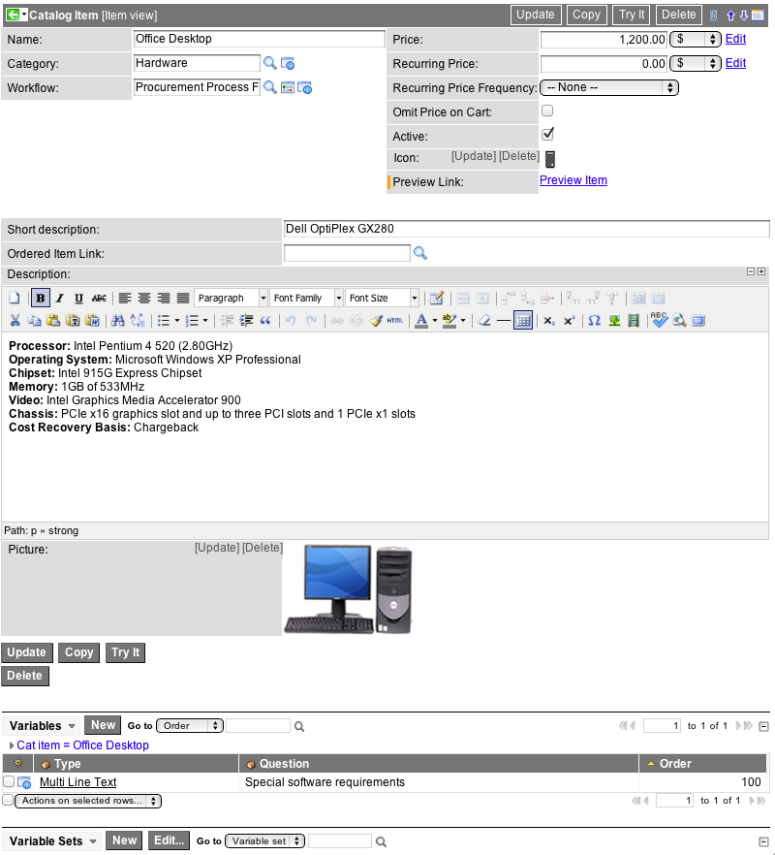](https://wiki.servicenow.com/index.php?title=File:Cspc-new.png)

1. Define [variables](https://wiki.servicenow.com/index.php?title=Using_Service_Catalog_Variables) for the item, if applicable.

|  |  |
| --- | --- |
| **Field** | **Description** |
| Once a product is [defined](http://wiki.servicenow.com/index.php?title=Defining_a_Product_with_Release_Management), a release can be planned and executed. The steps in managing a release process are:   1. **Planning the release**: defining the Release record, and the release phases. 2. **Scoping the release**: defining features and feature tasks. 3. **Executing the Release**: performing the steps required to complete the release.   **Import Sets** is a powerful tool used to import data from various data sources, and then map that data into ServiceNow tables. The Import Sets table acts as a staging area for records imported from a data source.  A [**transform map**](http://wiki.servicenow.com/index.php?title=Creating_New_Transform_Maps) determines the relationships between fields displaying in an Import Set table and fields in an existing ServiceNow table, such as the Incidents or Users table.  Importing sets will skip records when the data in the instance matches the data being imported. |  |

An import set acts as a staging table to store raw data from an external source. The import process uses a [transform map](http://wiki.servicenow.com/index.php?title=Creating_New_Transform_Maps) to add or update data from the import set to an existing ServiceNow table such as incident or problem.

Use import sets to:

* Manually import data from a file on your local system
* Manually import data from a data source
* Periodically import data from a data source with a scheduled import
* Programmatically import data from a file with a script
* Programmatically import data from a web service

# Creating a Transform Map

A [Transform Map](http://wiki.servicenow.com/index.php?title=Creating_New_Transform_Maps) determines how data is mapped onto a ServiceNow table.

First it is necessary to specify a destination table and select a method of mapping. Under the right circumstances where field names in the Import Set and the destination table are identical or nearly identical this is a simple as clicking the "Auto map from matching fields" button. If any fields are not mapped by the auto matching utility then it is also possible to specify mapping relationships using a simple drag and drop interface by clicking the "Mapping assist" button. When using this utility it is possible to match one source field to multiple destination fields.

What

application

is

available

to

all

users?

A. Change

B. Incident

C. Facilities

D. Self--‐Service

(Answer:

D)

After

the

High

Security

plugin

is

activated,

a

security\_admin

privilege

is

created.

What

is

an

elevated

privilege?

A. Elevated

privilege

is

used

to

promote

extension

tables

B. Used

to

enable

the

ITIL

role

to

have

an

Admin

type

access

C. A

role

that

has

special

permissions

for

the

duration

of

the

log

in

session

D. Users

with

the

Admin

role

(Answer:

C)

In

a

SLA

definition,

which

one

of

the

following

is

a

condition

that

will

trigger

an

SLA?

A. Begin

Condition,

Stop

Condition,

and

Pause

Condition

B. Start

Condition,

Stop

Condition,

and

Reset

Condition

C. Start

Condition,

End

Condition,

and

Pause

Condition

D. Start

Condition,

Stop

Condition,

and

Pause

Condition

(Answer:

D)

Multiple

Choice,

Single

Line

Text,

and

Select

Box

are

what

type

of

elements

in

ServiceNow?

A. Order

Guides

B. Request

Types

C. Variable

Types

D. Related

Lists

(Answer:

C)

By

default

in

ServiceNow,

what

customizations

are

added

to

Update

Sets?

A. Changes

made

to

data

B. Changes

made

to

a

form

C. Changes

made

to

a

schedule

D. Changes

made

to

a

homepage

(Answer:

B)

What

is

a

Transform

Map

in

ServiceNow?

A. A

map

that

is

used

to

store

the

history

of

the

incident

records

B. A

map

used

to

add

data

to

encrypted

fields

C. A

map

used

to

trigger

Business

Rules

before

the

data

is

queued

in

the

outbound

Web

Service

D. A

map

to

determine

relationships

between

fields

displaying

in

an

Import

Set

to

fields

in

an

existing

table

(Answer:

D)

**Coalesce Field:** In an import, coalescing on a field (or set of fields) means the field will be used as a unique key. If a match is found using the coalesce field, the existing record will be updated with the information being imported. If a match is not found, then a new record will be inserted into the database.

Coalescence is the method by which import sets update existing records in a destination production table, rather than simply inserting new records. This means that when importing the data onto the targeted production table, the import set application attempts to match source values to currently existing target values on a production table for updating. Otherwise, a new record is created.

A field called **Coalesce case sensitive** in the Field Map form (*System Import Sets > Transform Maps > Field Map*) enables you to coalesce field values by case sensitivity.

**Case Sensitivity in Coalescence**

By default, field values marked as **Coalesce** are used in a case *insensitive* lookup for existing records. Case insensitive records update existing records only and do not cause new records to be created. If this check box is selected, ServiceNow attempts to match coalesce field values in import sets by case. If the case of a field in a record in the import set does not match the case in a value in an existing record, a new record is created.